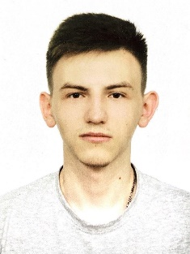Photo

Contact

|  |  |  |  |  |
| --- | --- | --- | --- | --- |
| +380973721753  meleshchuk_ak16@nuwm.edu.ua  Rivne, Ukraine | | | Meleshchuk Serhii | |
|  | | Test Automation Engineer | | |
|  | | | | |
| Summary of Qualifications | Graduate of computer science with experience working across the front-end of software development. I can grow and continue to learn from other experienced team members. Ready to learn automated testing and start a career in this field. | | | |
|  | | | | |
| Skills | **Hard skills**  **Programming languages / technologies:**   * C++/Win API * Python/Django * JavaScript/ReactJS * C#/Windows Forms   **Development tools:**   * Visual Studio Community Edition * Visual Studio Code   **Soft skills**   * Communication * Creativity * Ability to work in a team   **Languages**   * English A2 – pre-intermediate * Ukrainian - native | | |  |
|  |  | | | |
| Experience / IT related educational practice |  | | | |
| Project Name: | **Online System Auction** | | | |
| Project Description: | The project is designed for users who will be able to trade online. | | | |
| Involvement Duration: | 3 months | | | |
| Project Role: | Client-server model | | | |
| Responsibilities: | • To make client-server | | | |
| Project Team Size: | 4 team members | | | |
| Tools & Technologies: | Django, Python, C# | | | |

|  |  |
| --- | --- |
| Certifications |  |

|  |  |
| --- | --- |
| Education | **Master's Degree, Computer Science and Information Technology**  National University of Water Management and Environmental Sciences  Automation, Cybernetics and Computer Engineering  September 2020 – until now  **Bachelor degree, Computer Science and Information Technology**  National University of Water Management and Environmental Sciences  Automation, Cybernetics and Computer Engineering  Graduated in 2020 |